

**HILTI 2020 COMPETITION**

**GROUP NAME: ENTERPRISE GROUP**

**HAPPY HOUR APPLICATION**

|  |
| --- |
| **NAME** |
| Obiechi Samuel Ebuka |
| Gulam Mohiuddin Abdul Qader |
| Muhammad Haziq Farhan bin Mohd Lip |
| Shohiduzzaman Shakil |
|  |

1. INTRODUCTION 2

* 1. Purpose 2
  2. Scope 2
  3. Definition, Acronym, Abbreviation 2
  4. Role Distribution 3

1. Overall Description 4
   1. Product Perspective 4
   2. Software Requirement 4
   3. Hardware Requirement 4
   4. Functional Requirements 4
2. System Architecture 7
   1. Use case Diagram …...…………………………………………………………………………………………………………8
   2. Class Diagram …………………………………………………………………………………………………………………….9
   3. Sequence Diagram …………………………………………………………………………………………………………….10

4.0 System Design 10

4.1. Sign Up Interface 10

4.2. Sign In Interface 11

4.3. Staff’s Interface 12

4.4. User’s Interface 13

4.5. Outlet Intro Interface 14

4.6. Outlet Point Interface 15

4.7. Choose Product Interface 16

4.8. Product Details Interface 17

# **INTRODUCTIO****N**

With the current global situation (COVID-19) which has redefined the way we interact and perform daily activities; like people have to stay indoors and if there’s something to do outside, avoid crowded places, maintain social distance, wear facial masks and regularly wash and sanitize your hands. This situation has seen a lot of people stay indoors with an increased use of internet to communicate, perform tasks like shopping and more. Happy Hour is an application designed to allow user get shop for whatever is needed from their homes and get it delivered from the shop to their homes via a drone to avoid human contact and ensure the safety of our users. It has Robot web Services integrated into it to enable that functionality. And to encourage users to make use of the system more to reduce outdoor activities we provide a gift functionality which sees a user eligible to receive gifts after acquiring points by shopping with the app for a number of times. For the sake of this project, we are going to focus on the functionality of the application to use location service to deliver gifts from shops on the sites to user when they are on company site.

## **PURPOSE**

The purpose of this project is to define the future of remote work and collaboration in the construction industry through developing new and secure remote work solutions, investigating future working and collaborating solutions, overcoming the problem of remote work and collaboration and provide an innovative solution to allow companies such as HILTI to serve its customers better. Happy hour ticks all these boxes and more as a development team we are designing an application that is secure to access remotely, defines a new era of remote collaboration and provides solution for all challenges hindering productivity and quality of remote work and collaboration.

.

## **SCOPE**

The scope of this project are the part of the system we are going to focus on.

* User has 1000 points and is eligible to redeem gifts
* System checks is user is authorized and eligible to redeem gifts
* User chooses gift to redeem
* System uses location service to identify user’s location and sends information of gift and user details to the drone using RWS.
* Drone picks up correct gift redeemed by user and proceeds to deliver it to user using location.

## **DEFINITION, ACRONYMS, ABBREVIATION:**

## JAVA -> platform independence

* + - SQL -> Structured query Language
    - DFD -> Data Flow Diagram
    - CFD -> Context Flow Diagram
    - ER -> Entity Relationship
    - IDE -> Integrated Development Environment
    - SRS -> Software Requirement Specification
    - HTTP -> Hypertext transfer protocol
    - XHTML-> Extensible hypertext markup language
    - RWS -> Robot web services
    - JSON -> JavaScript Object Notation
    - REST -> Representation State Transfer

## **ROLE DISTRIBUTION**

|  |  |
| --- | --- |
| **Role** | **Person in charge** |
| UI/UX Designer | Shakil |
| System Analyst | Haziq |
| Programmer | Obiechi Samuel Ebuka |
| System Architect and Quality Engineer | Abdul Qader |

# **OVERALL DESCRIPTION**

* 1. **PRODUCT PERSPECTIVE**

The proposed system application will make use of location services ascertain users location and deliver the gift from the shop to the user via a drone making use of the integrated RWS.

* 1. **SOFTWARE REQUIREMENT**
* Front End: Android developer tool, Web development tool, Advanced Java
* Back End: RWS and MySQL
  1. **HARDWARE REQUIREMENT**
* Android version 5.0
* 2gb ram minimum
* 1.2ghz processor
* Intel i5
* Windows os
* Mac os
* I os
* Drone
  1. **NON-FUNCTIONAL REQUIREMENT**
* **Usability Requirement:**

The system should be accessed by users from their phones and computers. The system should be easy to use by all users and no special training is required. The systems interface should be simple but attractive, organized, easy to learn and recognizable, with necessary information displayed to user.

* **Availability Requirement:**

The system should be available 100% for the user anywhere with internet connectivity and is used 24 hours a day and 365 days a year. The system shall be operational 24 hours a day and 7 days a week

* **Efficiency Requirement:**

Mean Time to Repair (MTTR) - Even if the system fails, the system should be recovered back up within an hour or less.

* **Accuracy:**

The system should accurately provide real time information taking into consideration various concurrency issues. The system shall provide 100% access reliability.

* **Performance Requirement:**

The information is refreshed depending upon whether some updates have occurred or not in the application. The system shall respond to the member in not less than two seconds from the time of the request submittal. The system shall be allowed to take more time when doing large processing jobs. Responses to view information shall take no longer than 5 seconds to appear on the screen.

* **Reliability Requirement:**

The system should be 100% reliable due to the importance of data and the damages that can be caused by incorrect or incomplete data. The system will run 7 days a week, 24 hours a day.

* **Portability Requirement:**

The system should be able to run on various computers and phone and also run flawlessly on iOS, android, windows and mac. The system should be able to adapt based on its environment and also its user interface should also adapt to the device.

* **Security Requirement:**

The system should be able to refuse access to unauthorized users. The system should be also be able to protect user data and prevent malicious software’s from corrupting it.

1. **SYSTEM ARCHITECTURE**
   1. **USE CASE DIAGRAM**

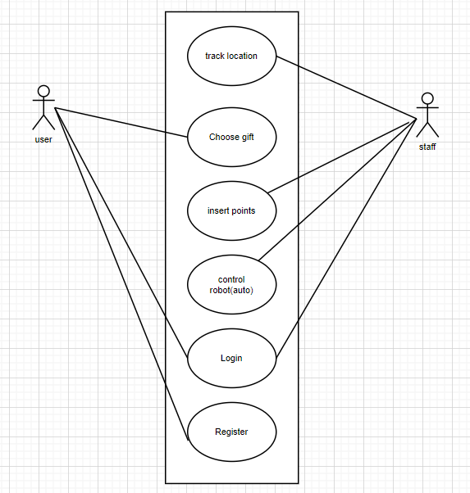

In this diagram the user can access the ability to choose gifts, as well as login and also register while staff can access the robot control, insert points and track location to the sending site.

* 1. **CLASS DIAGRAM**

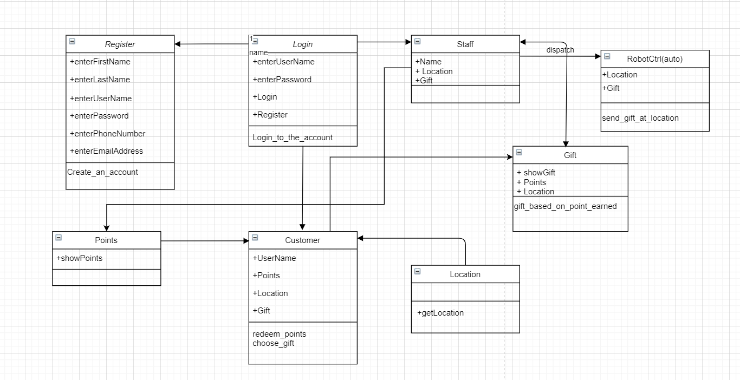

Above is the class diagram of our app. Here the customer will be welcomed with a login request. If the customer/ user does not have an account he or she can make an account simply by clicking on the registration link. After the registration the customer can login the system. Moreover, if a customer/ user already has an account that means that account will also have some points. With those points the user/ customer can get gifts. But the gift will be redeemed based on the point that was accumulated in the account. Once the user/customer redeems the point for a gift, the staff will get a message and will send the gift through the robot. The location will be sent along the gift that was requested by the user/ customer. The robot will need the location to locate the user/customer, and execute the operation.

* 1. **SEQUENCE DIAGRAM**

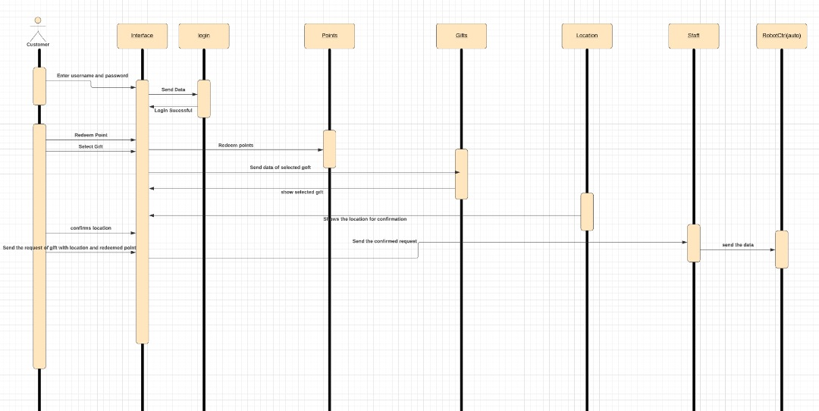

Above is the sequence diagram of the app. It is a simplified version. It shows the basic interaction of the class and how it performs and sends the messages. The user/ customer login to the system. A login successful message will be displayed. Moreover, it will show how much points I accumulate and gifts can be redeemed. Using those points users/customers will get gifts. Gifts will be provided based on ranks. Once the gift is selected the user will confirm the location and make the request. That request will go to the staff and the staff will send the gift through a robot.

**d. PACKAGE DIAGRAM  
  
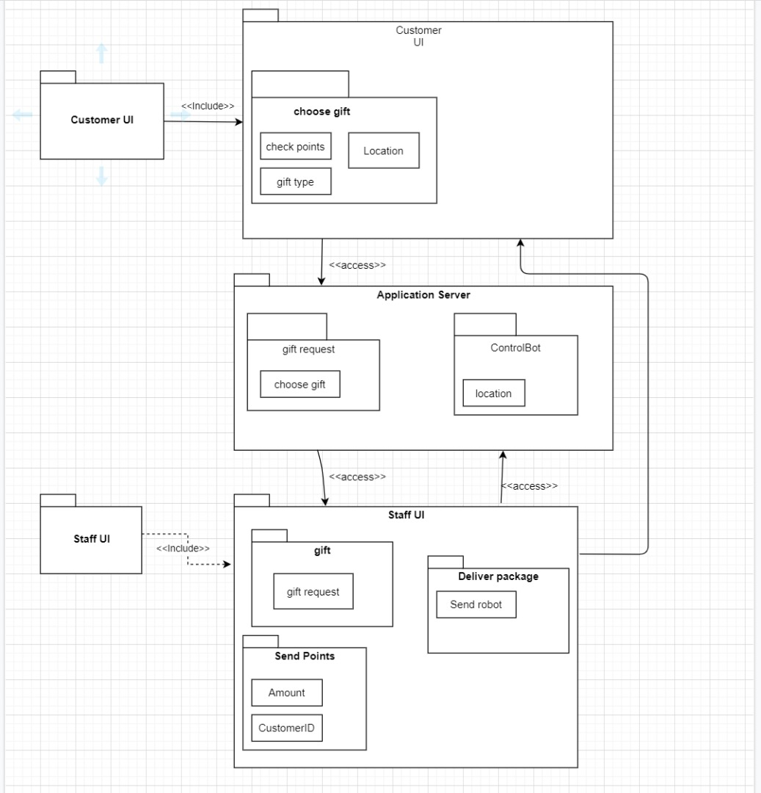**

The customer UI is consisting of a choose gift features which contains functions such as gift type for handling user’s gift choice, check points to see the number of points available left and also location which prompts the user to type in a location of delivery for the robots to go to.

The customer UI then connects to application server where the business rules services will be handled. In this case, we only featuring the main functions of our app that is gift request handler which handles the gift request from the customer.

The other features are ControlBot is controls the Robot’s AI using scripts based on the location the customer wants it to send the gifts. The staff UI will handle the incoming gift request from the user and send the available robots using commands in the UI. Staff can also send points to the user, by requesting amounts and inputting the names of the user. Lastly, the deliver package is used to command the robot to send the gifts to the user.

**e. DEPLOYMENT DIAGRAM**

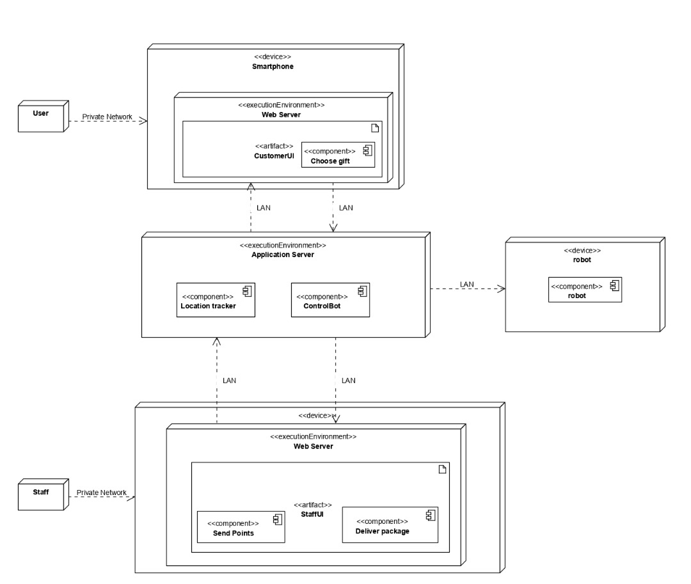

The customer UI will be deployed in the Web Server which then will be deployed inside the app which the user installs in their smartphones, choose gift will the components inside the CustomerUI.

The application server will be deployed in the execution environment like Apache Server for instance. Then, inside the Application Server there will be two components inside it, that is ControlBot and Location Tracker which will be using google maps as a location reader.

The ControlBot will then send a script command to the robot which will then have its AI be controlled automatically to the location send by customer.

The staff UI will be deployed in the devices like a computer by installing it. The Staff UI then will consist of the two main components of the app that is Send Points and Delivery Package. Both of these will be handled inside the Web Server.

1. **SYSTEM DESIGN UI/UX**

**4.1**

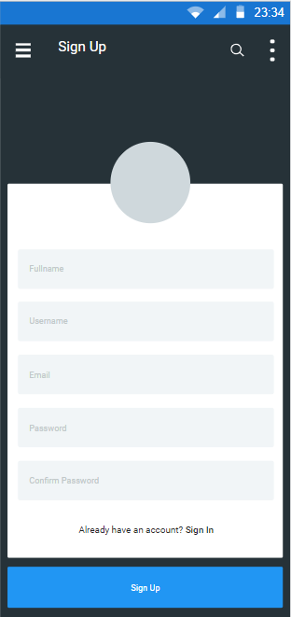

This image shows the registration page for the users.

**4.2**

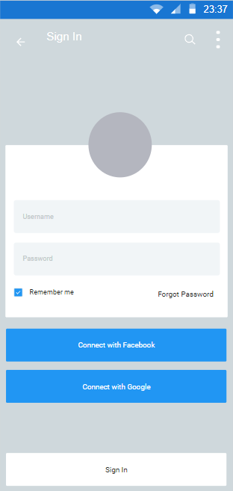

This image shows the login page for the users.

**4.3**

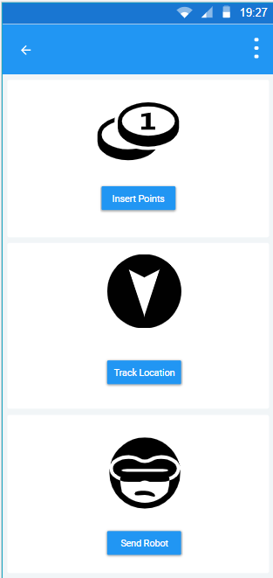

Above is the page which the staff can see. Once staff receive any request for gift from a customer, he/ she can see it and can forward it to the robot. In trace location staff can track the location of the robot. In insert point, staff can give redeemable points to the customer's account.

**4.4**

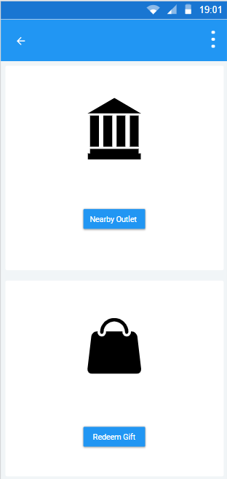

This image shows the option of nearby outlet and redeem gift option for the customer.

**4.5**

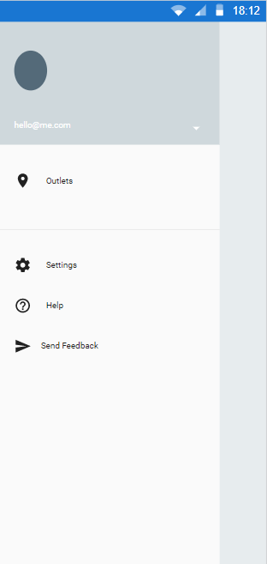

After the customer logs in he or she will be able to see this page.  here it shows the nearest outlet and other settings.

**4.6**

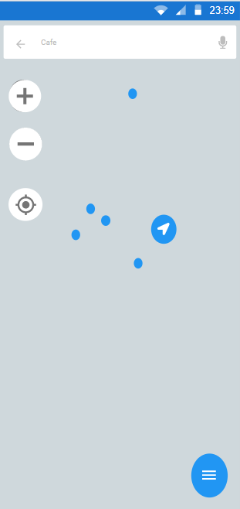

Above shows the location of the nearest outlet.

**4.7**

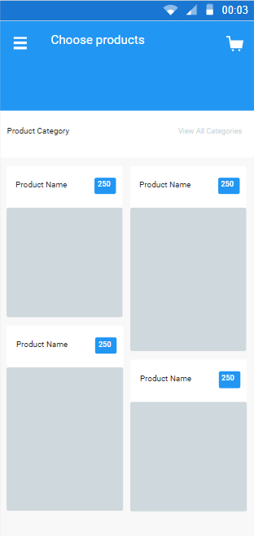

The picture in the above shows the product with picture and points required to redeem them.

**4.8**

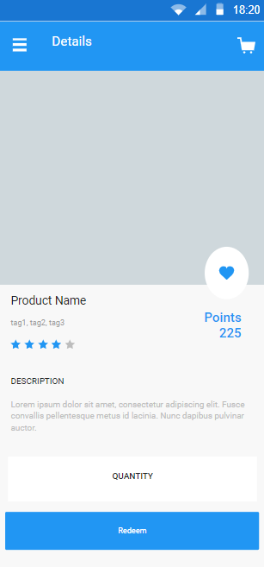

This picture shows the product discerption and quantity. It also shows to redeem the product option.